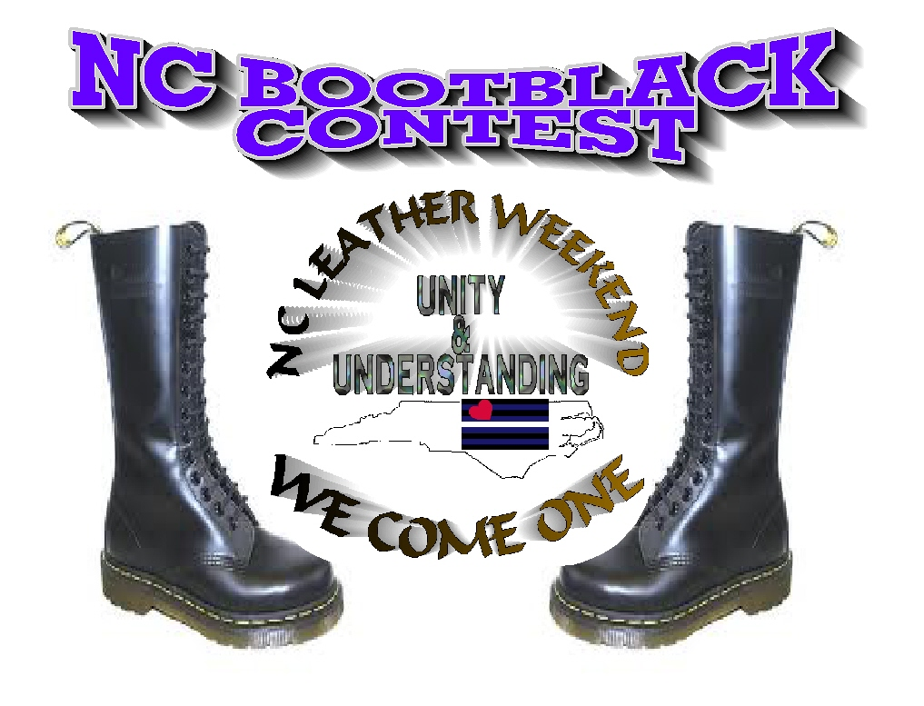
NCLWUU
NC BOOTBLACK CONTEST
Rules for North Carolina Bootblack Contest
- Contestants must be a resident of North Carolina.
- Contestants must be at least 21 years of age.
- This contest is open to any gender, sexual orientation, and any lifestyle
orientation.
- Each Contestant is required to have 2 Sponsors.
- Each contestant must agree to abide by the expectations of titleholders listed below in the titleholder contract, should he/she win.
- Each contestant must provide at Basket of items to be raffled off during the contest to help raise money funds which shall be applied to the titleholder travel fund. The fund will assist to cover titleholder expenses throughout the title year.
- Contestants must read and sign the contestant application, apply all fees required to enter the contest prior to the start of the contest. Contestants will receive free admittance to the NCLWUU event activities.
- Boot Blacking is about brotherhood and sisterhood. Cheating, ballot stuffing, and disrespecting the contest staff and judges or being intoxicated during the weekend will get you disqualified.
- All bootblack contestants are required to have a basket or item to auction off that will go to the North Carolina Bootblack Travel fund to help the winner represent North Carolina at various events. If you do not have means to do this please let us know we will find resources for you.
- All contestants are required to be at the contest on time. Contest times will be given upon receiving applications.
- Only the contestant that is signed up is allowed to compete and do boots. In other words no one from your support team is permitted to help you do boots during the contest.
PAGE1

NCLWUU / NC BOOT BLACK CONTEST SCORING INFORMATION

Judging Categories:
- Interview with Judges (20% points) – During the Interview category the questions may address any aspect of boot blacking, BDSM, Leather history, and the contestants specific life. The Interview category is not open to all attendees of the contest weekend. Contestants are expected to, NOT discuss these interviews with anyone until after the contest winner is announced.

- Technical Skills (30% points) - Each contestant will bring a pair of worn military style combat/jump boots capable of holding a high shine polish. These may be located at a goodwill/thrift type store, or perhaps you have an old pair. All boots will be assigned a number and contestants will draw a number to randomly select the boots that they will work on. The contestant will be required to shine one boot of the pair. A set amount of time will be allotted to carry out this task, following which the pair of boots will be put on display for viewing by the judges. The contestant must provide all necessary supplies for this task; the contest producers will provide a tarp for covering the floor. No open flame can be used except to singe stray strings.

- Interpersonal Skills (15% points) – Contestants will be observed by the judges throughout the weekend and will be judged on how they interact and present themselves as a bootblack to the public. Each contestant will be judged on their interpersonal interactions and skills throughout the weekend, including attitude, friendliness, courtesy, and cooperativeness. This category will be scored last.

PAGE 2

- Speech and Formal Wear (15% points) – Contestants will give a three-minute introductory speech on a topic of their choice during either the Friday or Saturday night event ceremonies. The contestant will also be judged on their formal leather dress during this time. Formal wear is what the contestant would wear to a formal leather event.

- On-stage question (15% points) – Each contestant will be asked a “pop” question on-stage during either the Friday or Saturday night event ceremonies. Contestants will have no prior knowledge of the questions asked. The question may or may not be related to boot blacking.

Scoring System:
- The bootblack contest is scored using straight scoring, meaning ALL judges scores count.
- In the event of a tie, Olympic scoring (dropping the highest and lowest scores from a judge in each category) will be used. A perfect overall score would be 550.

- A minimum of Seventy, (70) points must be attained to qualify for the title of “NC Leather Bootblack”.

- Scoring and judge feedback will be available to contestants within 30 days of the end of the contest.

- In the event that The NC Leather Contest title competition is limited to a single contestant,

That contestant must score a minimum of 70% of the total possible points (70 out of 100). The

Producers reserve the right to deviate from this procedure if they feel the circumstances

Warrant further consideration.

PAGE 3
NCLWUU-2013 Official Contestant Application
The 2013 North Carolina Bootblack Contest

This application and online registration (including non refundable $20 application payment) must be sent to North Carolina Leather Weekend by February 8, 2013.

INFORMATION ABOUT THE BOOTBLACK CONTESTANT

Full Legal Name:
Scene Name:
Address:
City: State: Zip:
Home Phone: Cell Phone:
Email Address:
Emergency Contact Name:
Emergency Contact Phone Number:
Emergency Contact Relationship:
Birthdate:
#1-Sponsored by:
Sponsor Address:
Sponsor Phone Number:
Sponsor Email: ___________________________________
Sponsor Contact: ______________________________
#2-Sponsored by: ______
Sponsor Address:
Sponsor Phone Number:
Sponsor Email:
Sponsor Contact: ______________________________________________________________

PAGE 4
Hobbies/Skills/Interests:

How long have you been involved in the Leather, S/M, and fetish lifestyle?

Current Title:
Other leather titles held and dates:

Club/Bar Affiliation:

Community organizations and charities involvement. (Include phone number, contact person and number of years involved. Expand this space if needed):

BDSM/Leather events attended during 2010-2012: (Expand this space if needed):

How have you integrated Boot blacking and Leather into your life and your relationships?
(Expand this space if needed)

Why do you want to be North Carolina Boot Black? (Expand this space if needed)

If you become North Carolina Boot Black, how will you integrate the commitments of the title into your every day responsibilities? (Expand this space if needed)

Please write a bio for the website and event program. Maximum 1000 words. No hyperlinks, please. (Expand this space if needed or place on separate paper):

PAGE 5

DISCLAIMER AND RELEASE OF LIABILITY: In consideration of the acceptance of our entry herewith by the owners the North Carolina Bootblack Title and producers of the North Carolina Leather Weekend – Unity & Understanding weekend, I hereby waive, release and forever discharge NCLWUU, Inc., its owner, producers, members, agents, operators, employees, lessors, lessees, parent companies or entities, affiliated companies or entities, representatives or subsidiaries from any and all demands, actions, causes of actions, claims of injury or damage to our persons, property or reputations, costs, damages, expenses, attorney’s fees or penalties of any kind or nature, whether asserted or unassertive, known or unknown, that may arise now or in the future from any cause whatsoever in connection with our participation in and with the North Carolina Boot Black Contest. I hereby give permission for the use of my scene name, photographs and videos in connection with publicity for North Carolina Boot Black Contest Bootblack title, contest and weekend. By my signature, I hereby state that I have read and understand the above disclaimer. I further state that I am at least 21 years of age.

Contestant signature: Date:

^{PAGE 6}
NC BOOTBLACK CONTESTANT CONTRACT
MUST BE SIGNED PRIOR TO CONTEST DATE

Acknowledgment of Titleholder Responsibilities:
- The North Carolina Boot Black titleholder will be expected to be a visible member of the North Carolina Leather and Kink community throughout his/ her title year demonstrating the "Art of Boot Blacking”.

- The North Carolina Boot Black titleholder should be willing to speak to all segments of the North Carolina , South Carolina , and East Coast region Leather/BDSM/Fetish community; with the understanding that he/ she is representing as an Ambassador of an all inclusive and diverse contest title.

- The titleholder is required to have a title platform that will not misrepresent the title nor misrepresent the community .The producer(s) will be supportive and of assistance toward the titleholder’s the chosen platform.

- The titleholder will be required and expected to attend a minimum variety of 10 Leather/BDSM/Fetish and LGBT-Q events and organizations including within the state of North Carolina, South Carolina, and East coast region to support and be active through education, assistance with fundraising, and/or the sharing of ideas and experiences.

- The titleholder is required during the duration of his/ her title year to attend the listed events NC Leather Contest, Leather History Conference, SC Leather Contest, Leather Ball, and Southeast Leather fest.

- The titleholder is to exhibit the highest possible standard of professionalism. All commitments made on behalf of the title must be fulfilled – if extenuating circumstances will prevent you from following through, you must do your best to inform all relevant contacts promptly. In an emergency situation, your producers are available to assist you in doing so. You must be punctual and presentable at all times. As you represent your title and your contest at all times, you must abide by any/all guidelines, rules or requirements of any event you attend.

PAGE 7

- The North Carolina Boot Black titleholder is expected to maintain contact with the contest producer(s) throughout the title year to keep them informed of titleholder activities. Executive Committee, reserve the right to determine or finalize the content of any fundraisers, demonstrations, workshops or other events, its budget if any, any promotional materials and information pertaining to the fundraisers, demonstrations, workshops or other events.

- The titleholder will have the full support of the contest producer(s) throughout the title year. The. North Carolina Boot Black titleholder will be expected to assist with contest publicity as well as the publicity for any events associated with the NC Leather Weekend- Unity & Understanding / NC Boot Black Contest throughout the year.

- The titleholder will complete his/ her title term of one (1) year. The titleholder will be expected to attend and compete at Southeast Leather Fest within a 2 year period after his/ her reign. Following the title year known as “step-down” will occur during the North Carolina Leather Weekend-Unity & Understanding 2014 event weekend. The titleholder shall participate on the judging panel for NC Boot Black competition in 2014.

- The North Carolina Boot Black titleholder will receive a travel fund in the minimum amount of $250 (Two Hundred and fifty dollars) up to the maximum amount of $500 (Five Hundred Dollars).The North Carolina Boot Black titleholder should understand that it will take time and money to accomplish the goals he/she sets for the year and may need to raise money or pay out of pocket to cover some of those expenses. The producers, however, will work with the titleholder to reach those goals without creating a financial hardship for the titleholder.

- One of the expectations that we have of our winners is that during his / her title year, he/she will
Conduct himself / herself as positive role models. Flagrant violation of this expectation may result in forfeiture of his/ her title.

- The titleholder shall practice and observe a Code of Ethics by conducting himself / herself in an honorable and trustworthy manner. While maintaining positive communications with all board members and the community at large. The titleholder will not participate in negative gossip, deceitfulness, and otherwise un-sportsmanlike behavior. While conducting himself / herself in a responsible manner at all times; and shall be accountable for all actions at public and private events. The titleholder understands that any violation of this agreement may result in the withdrawal and/or forfeiture of the title.

- Prior approval from NCLWUU, Inc. is required before the titleholder may use his/ her title for personal gain. This includes use of the title in advertising for pornography appearances, sex work and professional domination/submission work. The titleholder has standing permission to use his/her title for self-promotion for his/ her boot blacking work and activities, but still need prior permission from NCLWUU, Inc. for other usages.

- The titleholder must beware that many of the official appearances will occur in venues that sell alcohol. Consuming alcohol while representing your title is permitted, but the titleholder will be expected to use his / her best judgment and to exercise moderation. Whenever possible, you should avoid being photographed with an alcoholic beverage in hand. Please refrain from becoming inebriated in public and never drink and drive. The use of illegal drugs in public is absolutely forbidden during your title year.

- Should the titleholder be found unable to fulfill the responsibilities of the NC Boot Black Title during his /her title year the NCLWUU, Inc., its owner, producers, members, agents, operators, employees, lessors, lessees, parent companies or entities, affiliated companies or entities, representatives or subsidiaries shall remove the him/her from the title allowing the runner up to obtain the present title.
Page 8
- Should the titleholder fail to perform his/her duties as specified, or is found to be in violation of any clause in this contract, NCLWUU, Inc., reserves the right to remove him/her from his/her position as NC Boot Black. If a titleholder is arrested during his/ her title year NCLWUU, Inc reserves the right to remove the titleholder from his/ her position – circumstances will be evaluated by the producers to determine if the situation warrants this action. Should the titleholder be removed from his/ her position, NCLWUU, Inc. may ask the first-runner up to serve in his/her place as titleholder for the balance of the title year. The removed titleholder must return all sashes, vests, belts, medallions and trophies pertaining to the revoked title immediately and forfeits any prizes not already redeemed.
Contestant signature: Date: TO BE SIGNED PRIOR TO THE CONTEST DATE
All contestants are required to complete this all forms with required signature, contestant entry fee of $20, and copy of your ID by February 8, 2013 in order to compete in the contest.
The $20 non-refundable fee is to secure intent as well as to help with cost of this contest.
Email or postal mail all required forms to:
NCLWeekend@inbox.com
NCLWUU Inc. 1031 Franklin Street Winston Salem, NC 27101
For additional information or questions, please contact:
North Carolina Bootblack Contest (nclweekend@inbox.com)

PAGE 9

